**NOTE: BEFORE STARTING THIS YOU MUST REGISTER IN NEW GERRIT**

Onetime activity:

Steps to setup GIT user profile:<https://confluence.devops.lloydsbanking.com/display/ET/4.+Work+with+Git+and+Gerrit>

Link to install GIT bash:

\\appdvstp025\STP Software\Git

\\Global.lloydstsb.com\file\D_COMMON0044$\Shared\Rig Create\SIP - T24\Software

Design studio: (if you not configured Design studio)

Window 🡪 Open Perspective 🡪 other

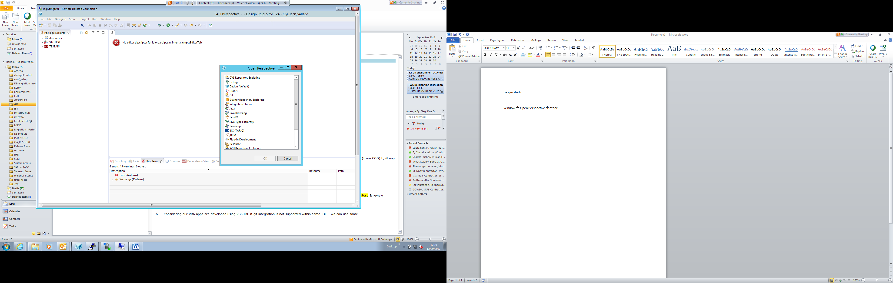

Choose GIT

After this we need to add the user details like user name and user email id please find the screen shot for the same.

Git->configuration

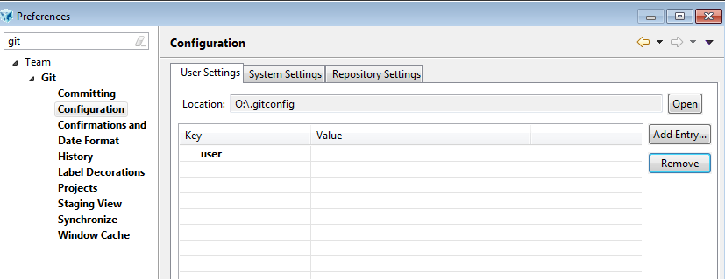

Click on Add entry

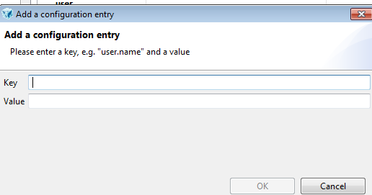

In the key update as user.name and in value update user name created in Gerrit (<http://10.59.151.120:9100>)

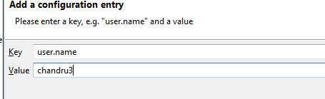

Once done click add entry once again to add the email id.

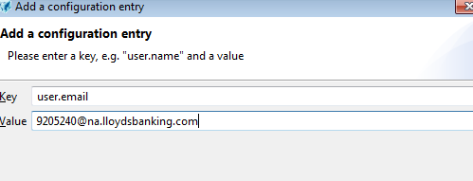

Click on ok to complete the process.

**If already cloned or configured :**

1. Close all the routine which are opened in the Design Studio
2. Right click on the **ocean-lbg[master]** and you will get the option of Delete Repository…

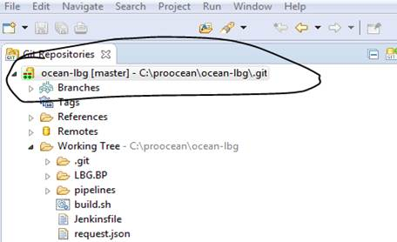

1. Once u click on delete reposity option you will find the screen as displayed below.

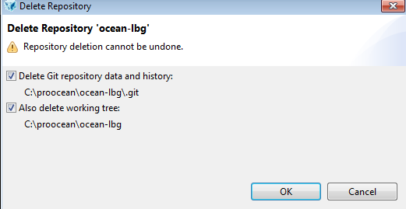

Tick both option as shown above and click ok, and press F5 to refresh.

This deletes the existing repository.

Now please clone the repository and steps given below.

**Clone repository from new gerrit:**

1. Go to path where you want clone or place ocean-lbg repository
2. Click right button of mouse , select Git Bash Here
3. Then enter below commands

**Note: ("Byresh" replase with your user name. which is register in gerrit)**

git clone ssh://Byresh@172.27.194.36:29418/ocean-lbg

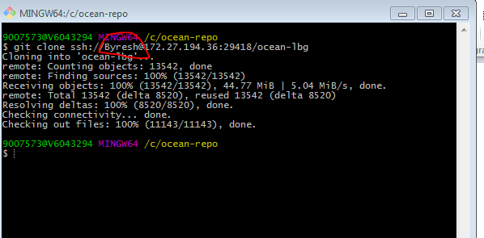

cd ocean-lbg/

git config --global remote.origin.push "HEAD:refs/for/master"

**Note: ("Byresh" replase with your user name. which is register in gerrit)**

git config remote.origin.pushurl "ssh://Byresh@172.27.194.36:29418/ocean-lbg"

curl -o .git/hooks/commit-msg <http://172.27.194.36:9100/tools/hooks/commit-msg>

git config --global gerrit.createchangeid "true"

git config --global remote.origin.fetch "refs/notes/*:refs/notes/*"

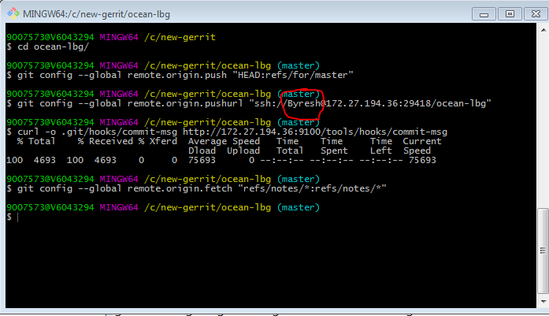

**How to add new repo in design studio:**

1. Go to design studio
2. Click on Add an existing local Git repository

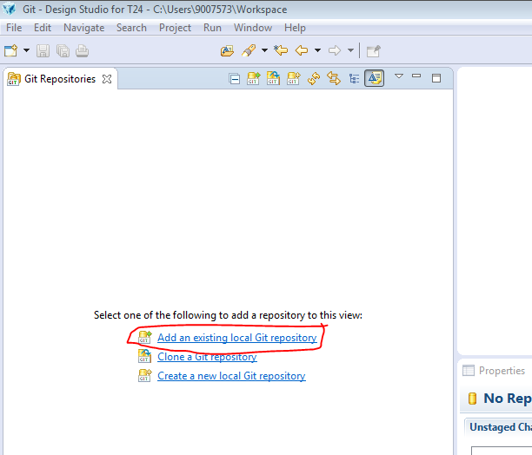

1. Click on browser button
2. Navigate to path where you cloned new repository
3. Select **ocean-lbg** and click ok

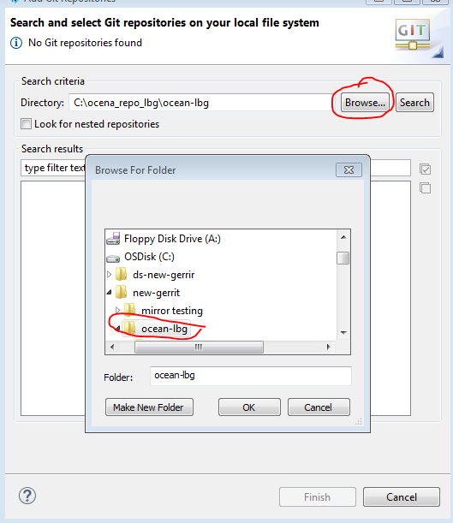

1. Check on box (you can see in below screen shot)
2. Click on finish button

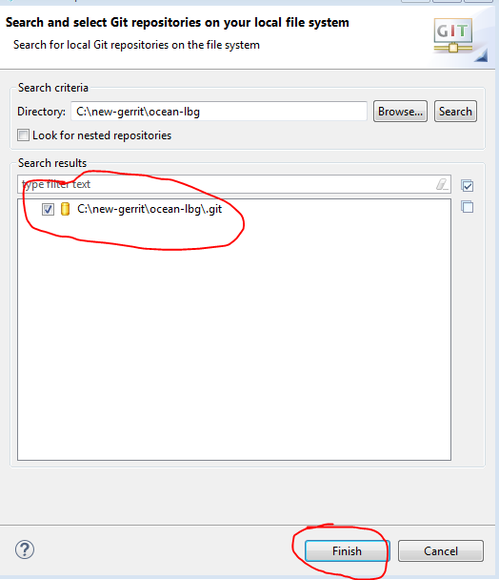

1. Now you can see new repository (like below screen shot)

